Test Case: tc002_SPX_Dev5_Crear_Requisicion_Spot_Tipo_Cobro_Project
Step 1 - Enter username and password and click to button Enter: Credentials Entered
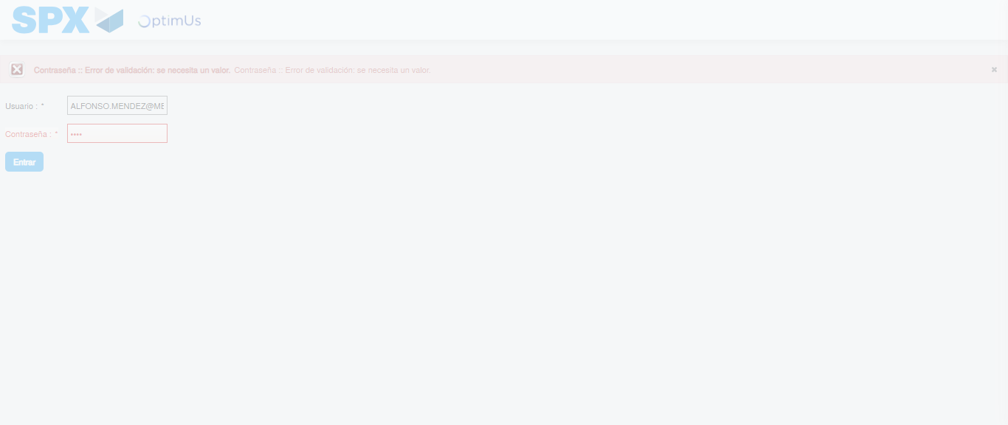Image file-name: QC_Testing-tc002_SPX_Dev5_Crear_Requisicion_Spot_Tipo_Cobro_Project-1783378134186

Step 2 - Select to UEN and Access to Spot Buy Requisitions : UEN Correctly selected and Correct access
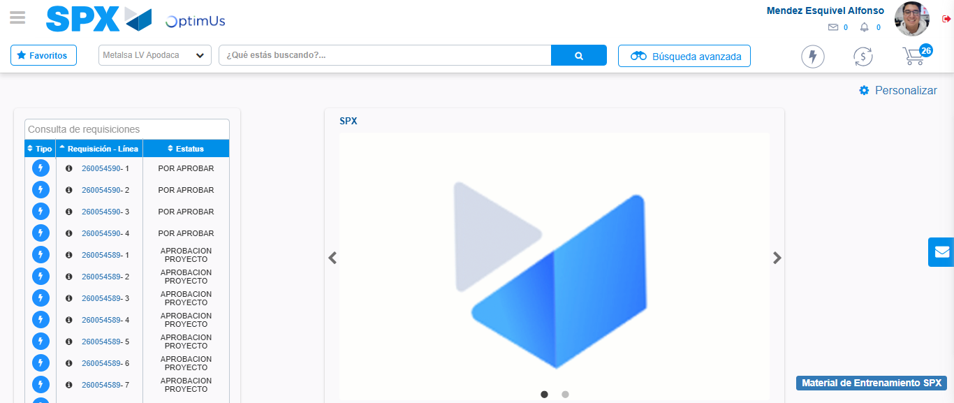Image file-name: QC_Testing-tc002_SPX_Dev5_Crear_Requisicion_Spot_Tipo_Cobro_Project-1783378159249

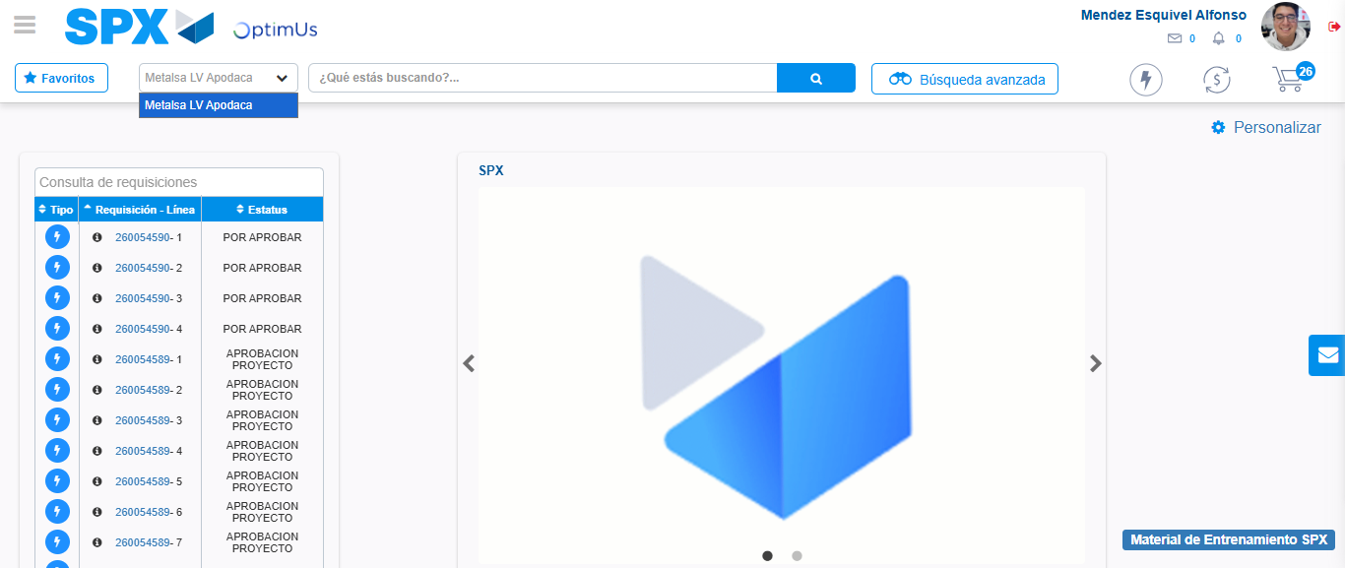Image file-name: QC_Testing-tc002_SPX_Dev5_Crear_Requisicion_Spot_Tipo_Cobro_Project-1783378161751

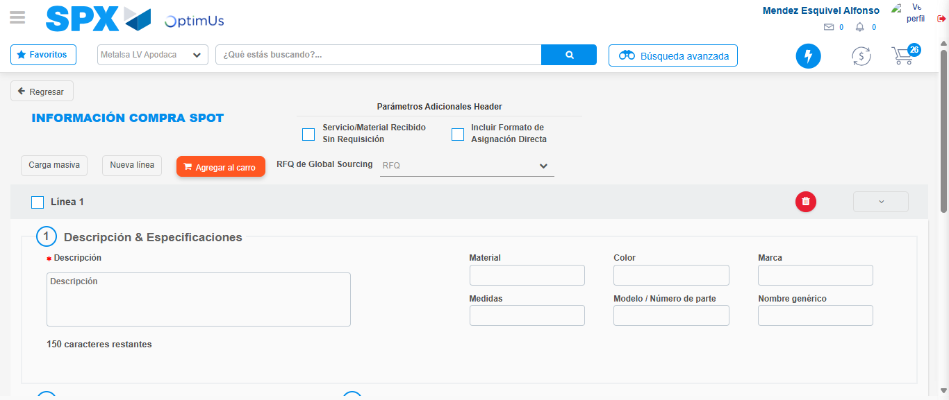Image file-name: QC_Testing-tc002_SPX_Dev5_Crear_Requisicion_Spot_Tipo_Cobro_Project-1783378182904

Step 3 - Data Capture Spot Buy Requisition: Data captured correctly
Image file-name: QC_Testing-tc002_SPX_Dev5_Crear_Requisicion_Spot_Tipo_Cobro_Project-1783378183122

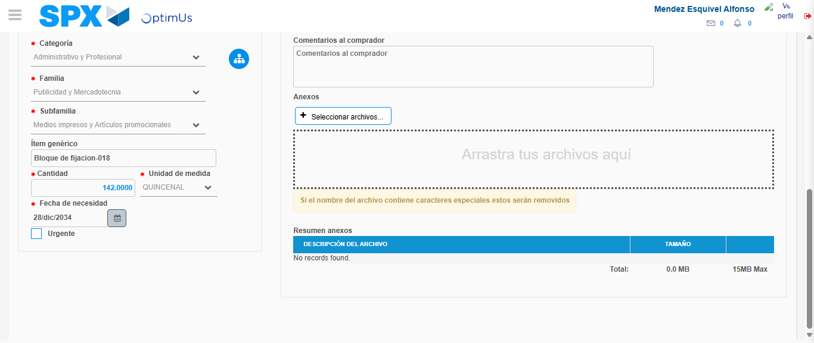Image file-name: QC_Testing-tc002_SPX_Dev5_Crear_Requisicion_Spot_Tipo_Cobro_Project-1783378193185

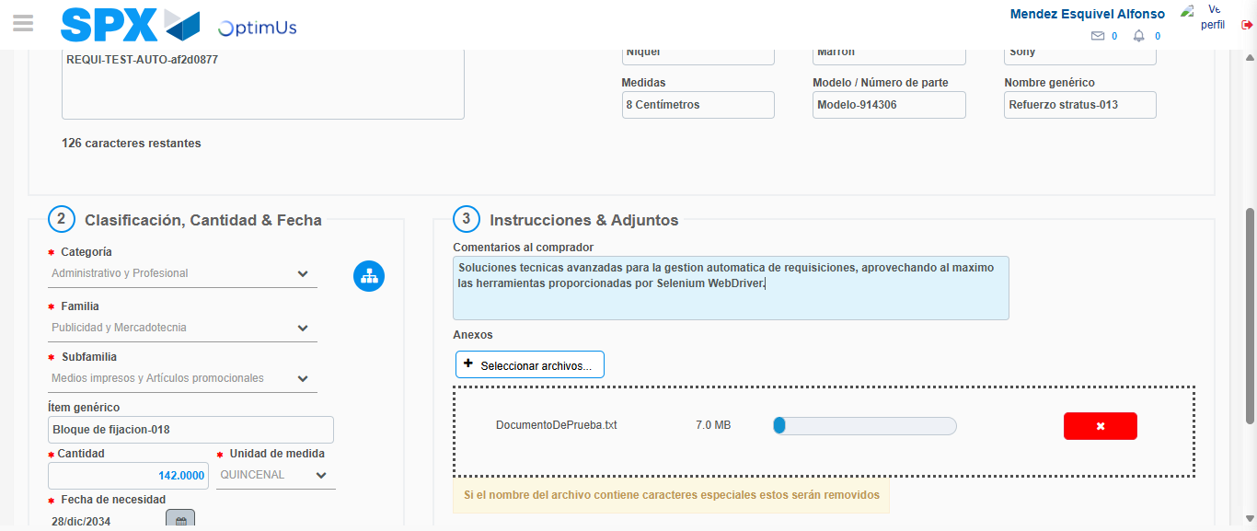Image file-name: QC_Testing-tc002_SPX_Dev5_Crear_Requisicion_Spot_Tipo_Cobro_Project-1783378193924

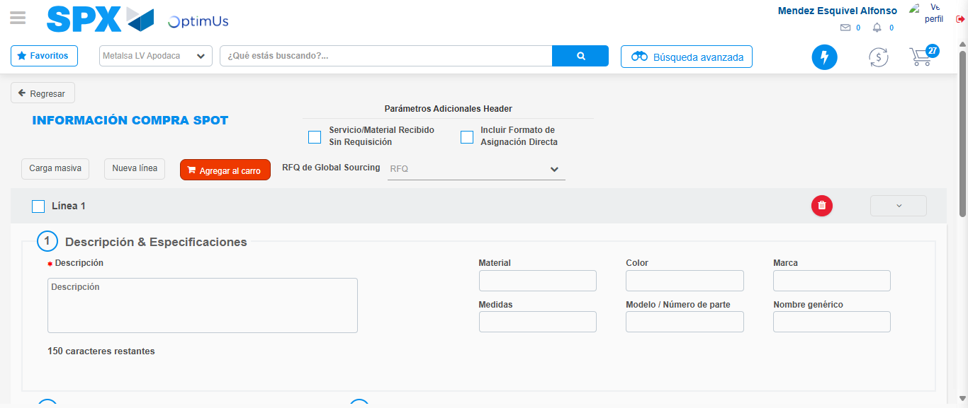Image file-name: QC_Testing-tc002_SPX_Dev5_Crear_Requisicion_Spot_Tipo_Cobro_Project-1783378199708

Step 7 - Return to Main Page SPX : Return to Main Page SPX
Image file-name: QC_Testing-tc002_SPX_Dev5_Crear_Requisicion_Spot_Tipo_Cobro_Project-1783378159249

Image file-name: QC_Testing-tc002_SPX_Dev5_Crear_Requisicion_Spot_Tipo_Cobro_Project-1783378161751

Image file-name: QC_Testing-tc002_SPX_Dev5_Crear_Requisicion_Spot_Tipo_Cobro_Project-1783378182904

Image file-name: QC_Testing-tc002_SPX_Dev5_Crear_Requisicion_Spot_Tipo_Cobro_Project-1783378201921

Image file-name: QC_Testing-tc002_SPX_Dev5_Crear_Requisicion_Spot_Tipo_Cobro_Project-1783378202084

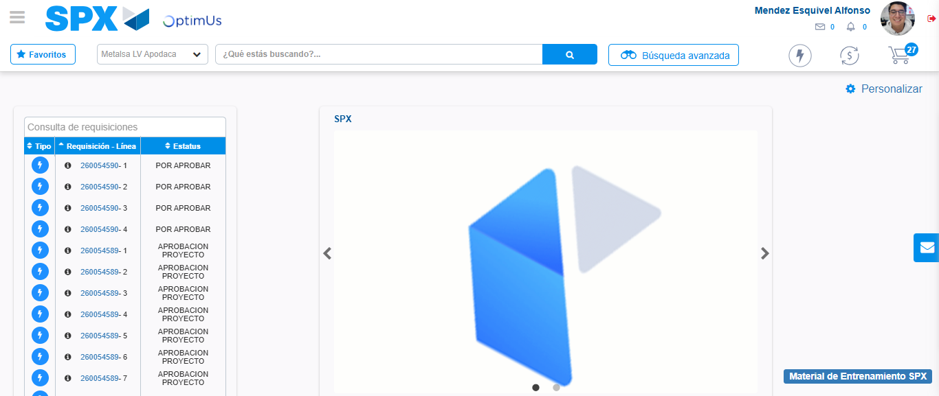Image file-name: QC_Testing-tc002_SPX_Dev5_Crear_Requisicion_Spot_Tipo_Cobro_Project-1783378223076

Step 8 - Log Out : Log Out SPX
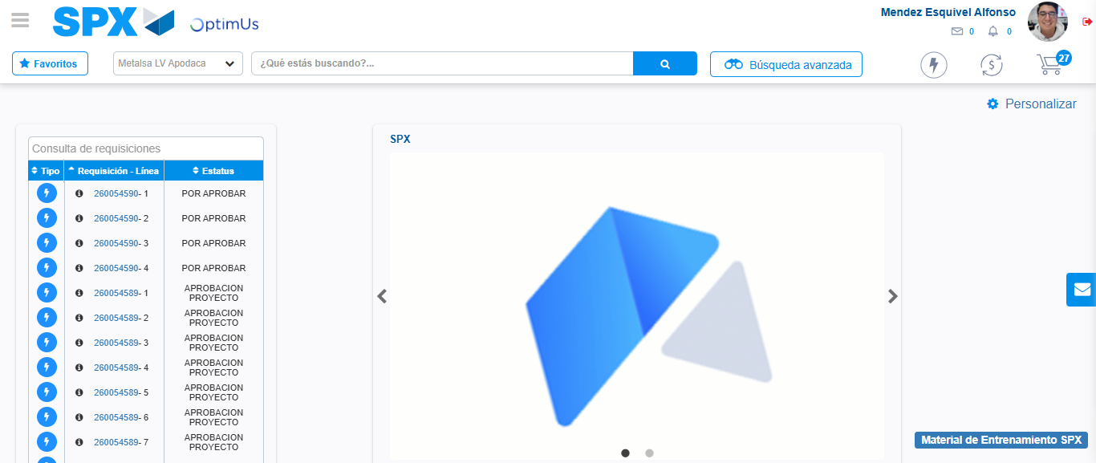Image file-name: QC_Testing-tc002_SPX_Dev5_Crear_Requisicion_Spot_Tipo_Cobro_Project-1783378223336

